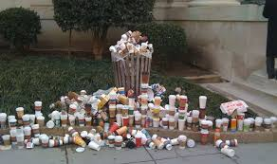
Run the Numbers.
At BAMBOOSTERS we understand the pressures that small business owners face. I’m a small business owner myself, and I know that those bills never stop rolling in. This is why our environment often takes a backseat to financial imperatives.
I visit a lot of cafes in the course of promoting BAMBOOSTERS and I’m often left wondering how they pay the bills. In my area, there are at least 25 coffee shops all competing for the morning caffeine rush. At an average cost of $4.50 per beverage they must be selling a lot of coffee to pay the rent, the staff and the utilities.
What has all this got to do with reusable coffee cups? The answer lies in the numbers. If you consider that a single use disposable coffee cup and lid may cost as much as $0.40 each, in a café that serves 200 cups a day, that’s $80.00 going straight to landfill every day! That’s a $400 a week! Wouldn’t it make sense to provide a profitable reusable cup option to your customers?
With BAMBOOSTERS, you will not only have a profitable sideline, but you’ll also demonstrate to your clientele that you have an interest in the environment that serves us all.
-Adrian.

